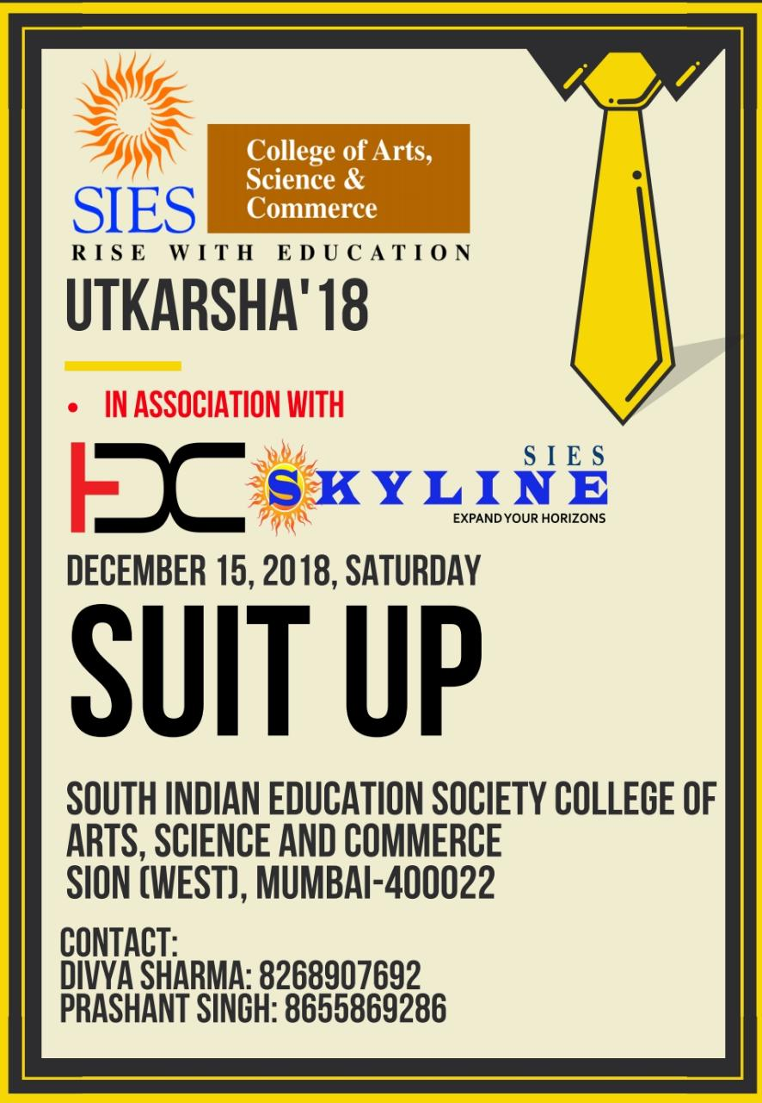
Utkarsha Event Report
Event name: Suit Up
Date: 15-12-2018
Venue: Room no. 29, SIES College of Arts, Science and Commerce (Autonomous)
Timing: 9:30 am to 2:00 pm
Participating teams: Nine (09)
No. of rounds: 3
Introduction: This year, the BMS department held its event ‘Suit Up’ in collaboration with Entrepreneurship Development Cell and SIES Skyline.
Different colleges took part in this event which had 3 co-related rounds where the teams were judged as per their performance and thereby eliminated to reach the final round of the game. After explaining the flow of the event and giving details about how the elimination would take place, the event thus began.
About the event:
Round 1: Jingle making
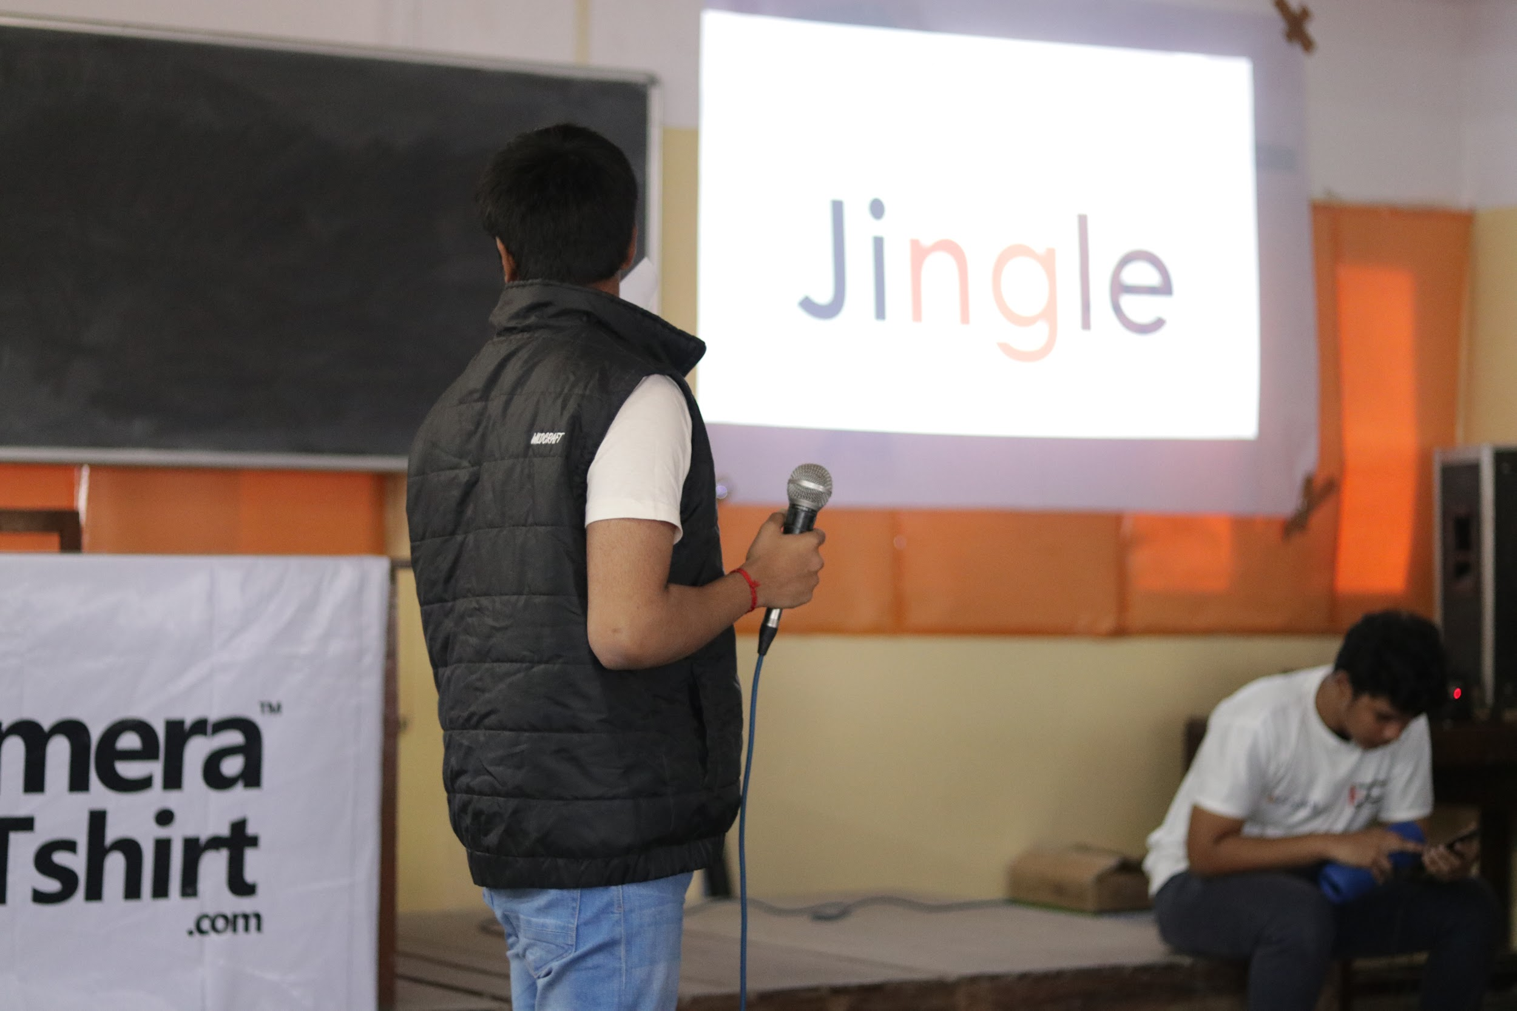
Participating teams: 9 Starting time: 9:45 am

Marketing through Jingles is one of the best ways to communicate a product to the targeted audience. In this round the teams were given a product each which they had to market to our Judge i.e., Prof. Saravanan Nadar. Products given were Speakers to teams 1, 2 and 4; Pen to the teams 3, 6 and 7 and teams 5, 8 and 9 were given soft drinks as their respective products to make the jingle upon. Preparation time given to each team was 15 minutes. Eventually, team 9 couldn’t clear the first round.

Round 2: Auction Round
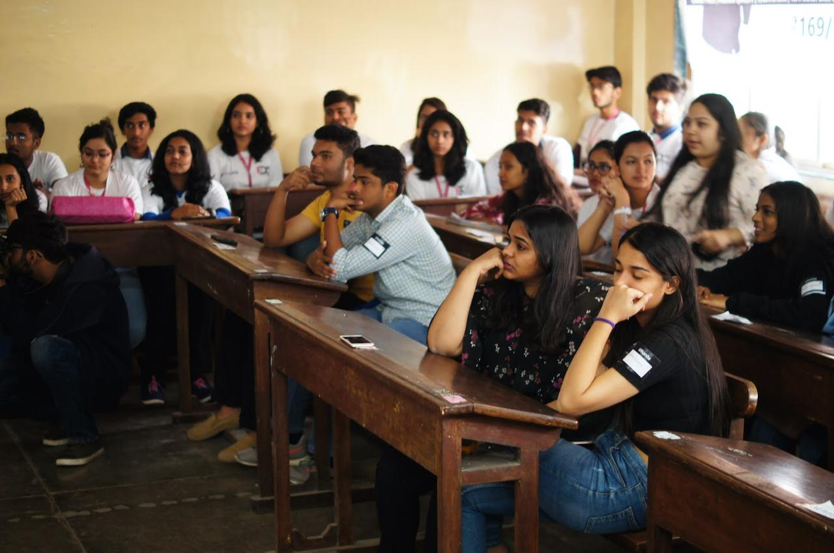
Participating teams: 8 Starting time: 10:30 am

The second round began where after understanding the created scenarios and situations, the selected teams had to bid on 20 different companies with a total of ₹1 crore as their base amount in bank. The winning team had 1 crore 80 lakhs at the end of the round. Thereafter, teams 5, 7 and 8 who had the lowest amount in bank were eliminated.

Round 3: Snake and Ladders
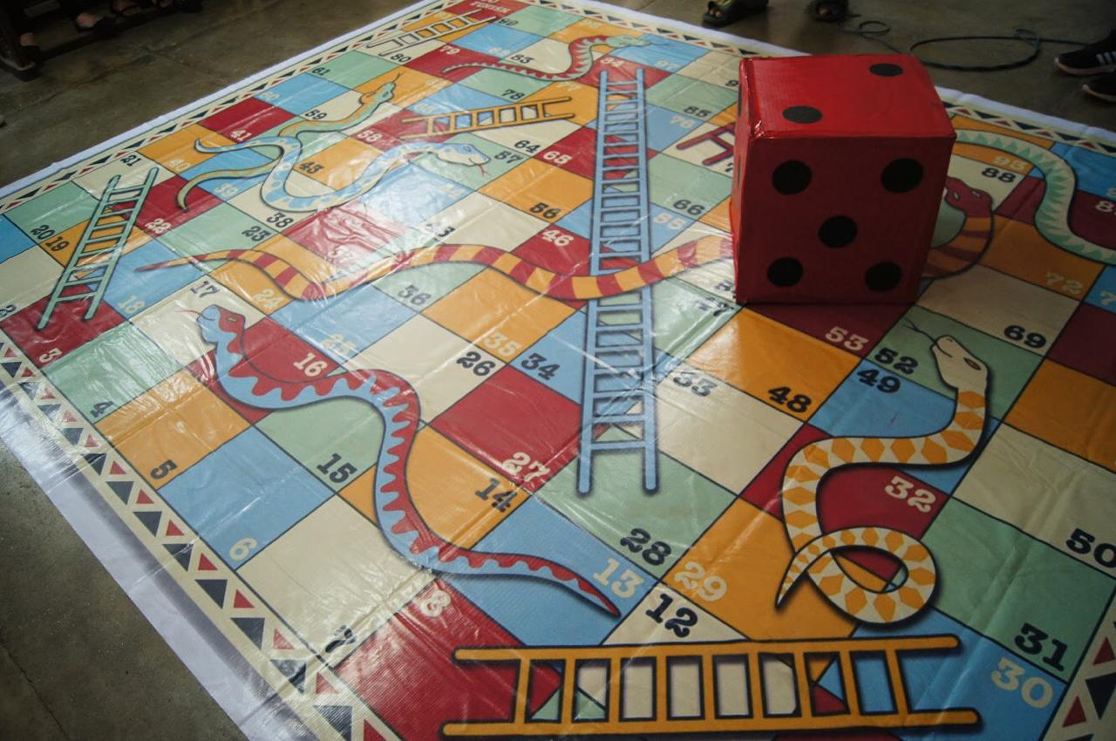
Participating teams: 5 Starting time: 12:00 pm
A life-sized snakes and ladders was made by the organising committee for this round. Every ladder had an opportunity for a particular company and every snake had a threat which according to the judges final decision may or may not lead to the tail. The teams had to roll a dice and move forward by answering the questions selected by them through picking a chit from the bowl when landed on an opportunity or a threat to their company. The Judges of this round i.e., Prof. Saravanan Nadar; Head of BMS Department, Mrs. Uma Kokku and Rishikesh Nair, Business Research Analyst of E&Y, selected team one as the final winner of the event.

Summary: This event helped the teams to get an overall upgradation of their skills. The first round was based on the writing skills, the second was based on the investment skills and the final round was based on the overall management skills. The different situational scenarios helped them in building up their team decision making which is a must to become a great entrepreneur.
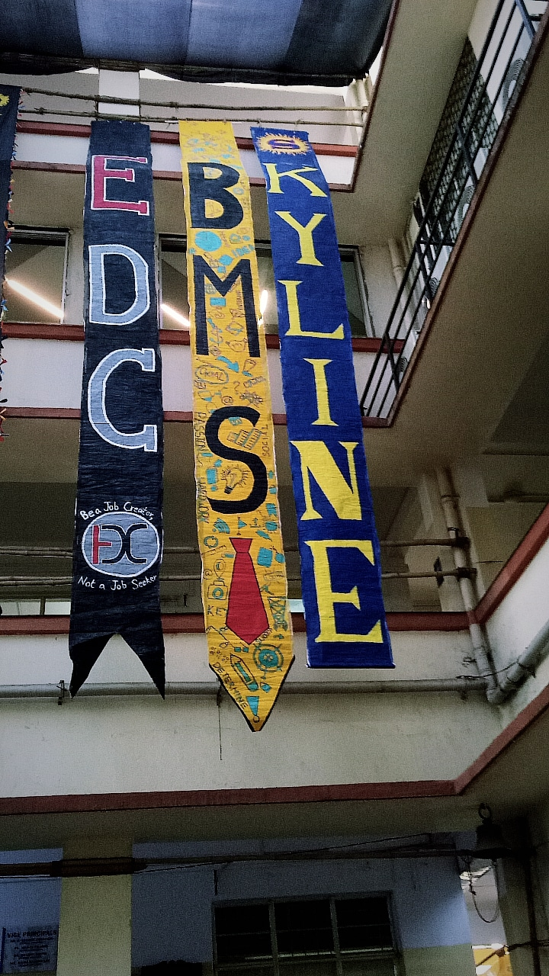
Prize: Winning certificate, Cash Prize of ₹1000 along with several coupons of Paytm, Shoppers Stop, Shein, Mojo, Chaayos, Wok Express and McDonalds Cards and book marks were given to the winning team. Participating certificates were given to every single participant.
